DOI: https://doi.org/10.15276/ict.01.2024.47
UDC 004.942 + 621.923
Mechatronic technological system based on CNC and
intelligent mechatronic mechanism
Vasily P. Larshin¹⁾
Academician of the Ukrainian Academy of Economic Cybernetics,
Dr. Sc., Professor, Department of Machine Dynamics and Mechanical Engineering
ORCID: https://orcid.org/0000-0001-7536-3859; vasilylarshin@gmail.com. Scopus Author ID: 7801669969
Anatoly M. Gushchin¹⁾
PhD, Associate Professor emeritus
ORCID: https://orcid.org/0000-0002-1289-9557; guschinanatoliy1@gmail.com
Oleksandr V. Lysyi²⁾
PhD, Associate Professor, Department of Military Vehicle Equipment,
Head of Department of Military Vehicle Equipment
ORCID: https://orcid.org/0000-0002-7389-1161; lenafox107@gmail.com
Sergii M. Verpivskyi²⁾
Deputy Head of the Department of Military Vehicle Equipment
ORCID: https://orcid.org/0000-0002-1610-4707; vsn1964@ukr.net
Egor V. Buchka¹⁾
PhD student, Department of Machine Dynamics and Mechanical Engineering
ORCID: https://orcid.org/0000-0003-4786-9283; yehorbuchka@gmail.com
¹⁾ Odessa Polytechnic National University, 1, Shevchenko Ave. Odessa, 65044, Ukraine
²⁾ Odessa Military Academy, 10, Fontanskaya Doroga Str. Odessa, 65044, Ukraine

АBSTRACT

A mechatronic technological system (MTS) has been developed. It consisting of a CNC metal-cutting machine tool and a mechatronic spindle, made on the basis of an intelligent mechatronic mechanism (IMM). The main elements of the technological system – the CNC and IMM devices – are parts of a single hierarchical, two-level control system, representing, respectively, the upper and lower control levels in this system. The upper control level – the CNC device – ensures stabilization of the kinematic parameters of machining (displacement, speed, acceleration) and their software change in accordance with the CNC control program. The lower control level – the IMM device – ensures stabilization of the power parameters of mechanical machining (cutting axial force and torque) and their software change in accordance with the technological requirements for the surface quality and the physical-and-mechanical state of the surface layer of the machined parts. At both control levels (the upper and lower ones), closed automatic control systems “by deviation” of the adjustable kinematic (upper control level) and power (lower control level) parameters of mechanical machining are functioning. Moreover, the automatic control system of the lower control level of the hierarchy in relation to a similar automatic control system of the upper control level, implements the method of automatic control “by disturbance”. This, in addition to directly ensuring surface finish and surface integrity, allows improving the quality of stabilization of kinematic cutting parameters at the upper control level. Experimental studies of MTS were carried out when machining parts from various materials (steel, polymer composite materials, superhard crystals and stones, other difficult-to-machine materials).
Keywords: vehicle repair technology, machining, smart cutting, axial cutting force, cutting torque, computer numerical control, intelligent mechatronic mechanism, linear actuator

Relevance. Effective technology for repairing cars and other vehicles is extremely important in wartime conditions. In turn, the effectiveness of the repair technology is determined by the appropriate means of technological equipment.
Having more than fifty years of experience in implementing the technologies discussed below in specific areas of industrial production (aspherical optics for ground-based telescopes, as well as mobile devices for aircraft, turbine blades for aircraft engines, manufacturing precision parts from grown single crystals used in control and measuring equipment, the essence of the above-mentioned technological processes was not disclosed in the open press until the end of the last century for reasons of secrecy. See, for example, Patent No. 1405189 “Machining method of blade edges”, as well as Patent No. 1478541 “Machining method of a turbine blade profile”. Last time the essence of numerous inventions on the above-mentioned topics begins to be covered in the open press, since the new scientific direction was under threat of closure due to the lack of opportunities to conduct
This is an open access article under the CC BY license (https://creativecommons.org/licenses/by/4.0/deed.uk)
further research in the field of creating a new generation technology for almost the entire technosphere (industry, space, medicine, sports, culture, etc.).
The newly created and modernized technological equipment with CNC demonstrated results in terms of accuracy, surface roughness and machining parts quality above the level of world achievements and was implemented in various areas of industrial production, the most significant of which are the following.
1. Production of aspherical optics from the blank to the finished product.
2. Finishing machining of the blades profile of the gas turbine engines (Institute of Electric Welding of the National Academy of Sciences of Ukraine named after Academician Paton, implementation act).
3. High-performance machining of critical parts from grown single crystals (Institute of Single Crystals of the National Academy of Sciences of Ukraine, implementation act).
A significant contribution to the problematic issues of the intellectualization of technological processes was also made in the following areas.
1. Dimensional machining of the shape-generating surfaces of dies and press molds.
2. Drilling thin deep holes with a diameter of less than a millimeter, for example, 0.3 mm.
The list can be continued, but in terms of achieving the required accuracy, it is worth emphasizing that fundamentally new technologies were created and implemented not as an alternative to existing ones (at that time), but due to the lack of any technical solutions for achieving nanometric accuracy.
Literature Review.
So far, in the theory of hierarchical management, there are no established rules and criteria for the interaction of different levels in terms of achieving an acceptable managerial result. Significant achievements in this field include the well-known rule of levels: management intelligence is hierarchically distributed in accordance with the “principle of increasing accuracy while reducing intelligence”, which is obvious in all hierarchical management systems [1]. The reaction of the mechatronic deviation feedback system to the occurrence of an unexpected deviation is delayed, and such a closed system is not ready for the upcoming accidental, i.e. unforeseen deviation [2]. In turn, the disadvantage of the operation of a faster mechatronic system “by perturbation” when controlling power parameters in the processing zone is the fact that during the execution of the dimensional processing program in places where the physical and mechanical properties of the processed part material change, dimensional errors occur in the form of sections of uncollected material [3].
Monitoring the cutting forces and torque helps both anticipating the tool’s fracture and controlling, including both detection of the tool wear types and thread quality control [4]. For each tap, a multivariate statistical process control chart is presented based on the principal components of the torque signal directly measured from the spindle motor drive to diagnose the thread profile quality [5]. However, the possibility of automatic torque control to reduce it (e.g., to reduce the tap wear) was not considered.
An integrated technological system is proposed with the following three levels of control: intelligent (upper), adaptive (middle), and robust (lower) [6]. However, nothing is said about the automatic control mechanism “by disturbance”.
The design of a mechatronic module (based on a linear actuator idea) is proposed, which contains two design variants of this module: a mechatronic transducer and a mechatronic power converter [7].
A solution to the problem of regulating the feed rate during point milling of complex-shaped parts is known [8]. When milling complex-shaped parts, the specified cutting conditions are not reached when the technological operation is set up for tools with a circular cutting edge. This is caused by the continuous change of contact point between the tool and the workpiece together with the fact that the cutting conditions are conventionally set to the tool reference point.
Once more article presents a method for optimizing the feed rate to maintain a constant feed per tooth. Implemented digital twin framework is presented by orchestration of CAM-integrated and containerized technology models carrying out FEM-coupled simulations for the finishing process of a simplified blade integrated disk (blisk) demonstrator [9].
The well-known control principles – “by deviation” and “by disturbance” – in modern control theory are accompanied by a new direction: distributed and hierarchical control systems with four system levels (from bottom to top): a component level, an information preprocessor level, an intelligent preprocessor level, and a top-level [10].
Essential control theory, transfer functions, and state space approaches in this theory are the base for developing the related systems mentioned above [11]. Besides, machine tools are mechatronic systems themselves [12]. Hence, they are open to including mechatronic mechanisms, but there are no hints of it. There is a design of a mechatronic electro-spindle containing a mechatronic actuator [13]. However, the hierarchy of the mechatronic servo system containing the machine CNC at the upper control level was not disclosed.
Measuring thrust force and torque during tapping helps overcome the tendency to adhere to the tool surface since the machinability of the hypereutectic Al-Si alloys is challenging [14]. The same applies to intelligent automated drilling in laminate composites and hybrid materials [15].
At the end of the review, it is necessary to mention works on a study of the quality of machined parts made of CFRP [16], composites in drilling [17] and generalizing work [18], as well as works on the physics of electromagnetism [19].
The paper aims to create an IMM design based on the electrodynamic coupling mechanism, which can be both a power and a sensitive element for automatic control “by disturbance” and “by deviation”, respectively.
Methodology. The proposed methodology and design of the IMM provide a technological breakthrough in the field of creating sensitive machining equipment with elements of intelligent control for smart mechanical processing of parts made of anisotropic materials. This scientific study, including theory and experiment, contains two stages of decision-making: analysis (qualitative, quantitative) and synthesis (based on the results of the analysis).
At the first stage, the object and subject of the study are analyzed. The object of the study is a technological operation, for example, drilling small-diameter holes in parts made of anisotropic materials. The subject of the study is a two-level (hierarchical) system of automatic control of kinematic and power parameters of mechanical processing.
At the second stage, technical systems-constructions and technical systems-processes are developed, which allow achieving the research objective. The systems-constructions include the IMM, which allows ensuring either stabilization of the power parameters of mechanical machining or their change according to the required technological program. For example, when the tool cuts into the part and exits the part, the specified values ​​of the power parameters are minimal. In the interval between these machining sections, the axial cutting force and cutting torque correspond to their specified optimal values.
This study is based on the use of three methodological directions: modeling, optimization and control. Modeling is implemented through the use of physical models – special samples and analog processes. The designed computer-graphic models will allow studying individual properties of complex processes while eliminating the influence of disturbing factors on them. Simulation of force and temperature factors on the graphical model will allow to establish relationships between the input and output parameters of the technological system, for example, the technological system for drilling small holes in the range of 0.3 – 3.0 mm.
The use of optimization methods is possible at the stages of production preparation and, actually, production. For example, at the stage of production preparation, optimization will be associated with the selection of elements of the technological system (machine, experimental setup, sensors, tool, blanks) and the selection of quantitatively changing machining parameters.
The control will ensure the appropriate functioning of the process, based on the provision of the necessary technological parameters – the accuracy and quality of the machined surfaces. The control is carried out in two forms: direct and indirect. Direct control includes monitoring, regulation, adaptive and intelligent control. Indirect control – diagnostics of the state parameters by the temperature criterion – will allow to avoid defects during machining.
Research results. The considered mechatronic technical system, including a CNC machine and a tactile-sensitive IMM installed on the vertical feed support of the machine, has one common spindle (ended by a cutting tool) that performs the following two functions.
1. During a stable cutting process, i.e., when the power parameters of the machining do not exceed the program-permissible limits (in the IMM system at the lower control level), the spindle is an integral part of a conventional CNC machine and is controlled by the CNC system (upper control level) in $XYZ$ coordinates. Therefore, the realized machining accuracy (by the size of the part) is determined only by the technical characteristics of the CNC machine.
2. When the actual cutting torque $M=M_{0}+∆M>M_{0}$, i.e., exceeds the specified value $M_{0}$. It means both the occurrence of “disturbance” $∆M$ in the cutting zone with an unchanged value of the cutting axial force $F_{0}$and the automatic “disturbance” elimination mode (Fig. 1).
In the smooth (stationary) movement of machine table with a programmed feed along the axis of the machine X along the trajectory $a-b-c-k-d-r$ in the section $k-m-n-p-r$ tool encounters an unforeseen obstacle (“disturbance”) in the form of an enlarged stock allowance with an unpredictable surface shape (Fig. 2).
Other things being equal, this will cause an increase in the machining current force parameters $F$ and $M$ in the area $k-m-n-p-r$. At the same time, the current force parameters $F$and $M$ will increase, respectively, by $∆F$ and $∆M$ exceed their predetermined values $F_{0}$ and $M_{0}$, i.e., the following inequalities will be met:
$F=F_{0}+∆F>F_{0}$, (1)
$M=M_{0}+∆M>M_{0}$, (2)
where $F_{0}$ is the programmed (at the lower control level) rated (designed) axial cutting force, N; $∆F$ is the additional accidentally occurred, increment of axial cutting force, H; $M_{0}$ is the programmed (at the lower control level) nominal (designed) cutting torque, N∙m; $∆M$ is the additional, accidentally occurring increment of the cutting torque, N∙m;
For example, let us consider the case when, while moving along the programmed trajectory $a-b-c-d-e$, the machining tool at any point $k$ lying on the programmed trajectory additionally touches with its peripheral surface the protruding unevenness of the increased allowance at point $m$ (Fig. 2).
This additional touch will cause additional increments of the force parameters $∆F$ and $∆M$. For example, in this case, there is simultaneously a cutting torque $M_{k}$ at a point $k$ and a cutting torque
$M_{m}$ at a point $m$ , i.e., the total cutting torque becomes greater than the programmed (nominal) one
$M_{0}$. Therefore, according to condition (1), it is possible to write
$F=F_{m}+F_{k}>F_{0}$ (3)
$M=M_{m}+M_{k}>M_{0}$. (4)
Exceeding the value of the actual cutting torque $M$ (above the programmed level $M_{0}$) causes the tool to automatically move up by value $z_{i}>0$in the moving coordinate system $xyz$ along the vertical axis $z$ and, as a result, the electrical stops-contacts are broken when the end of the armature is torn away from them.

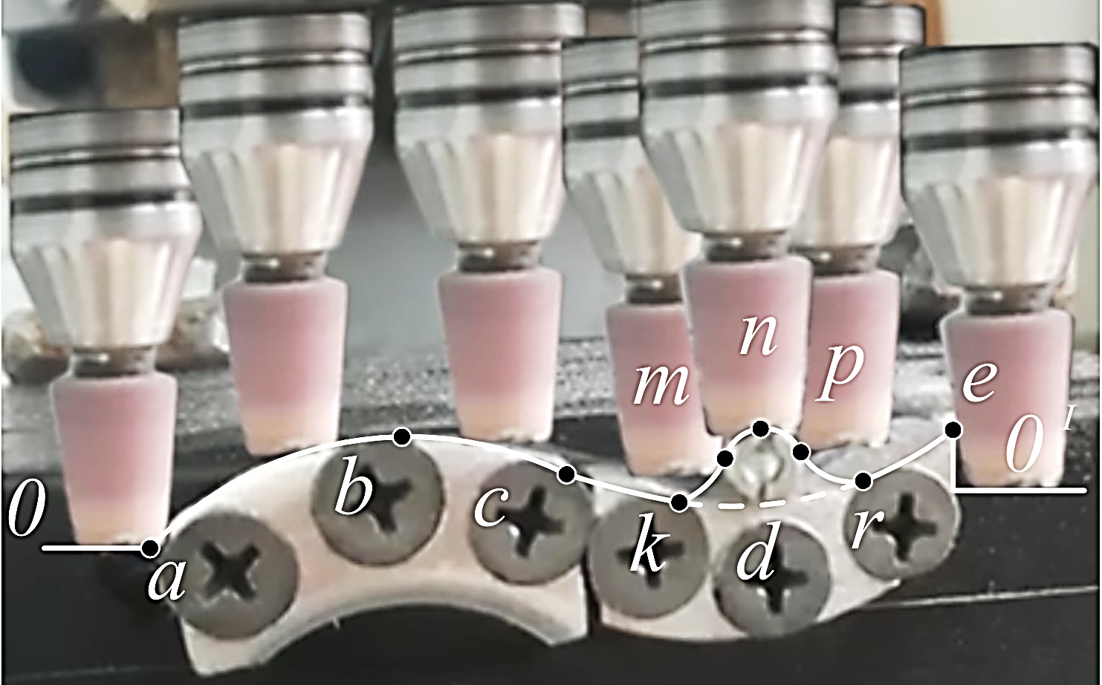  a  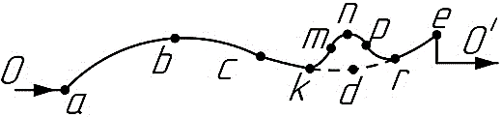  b |  | 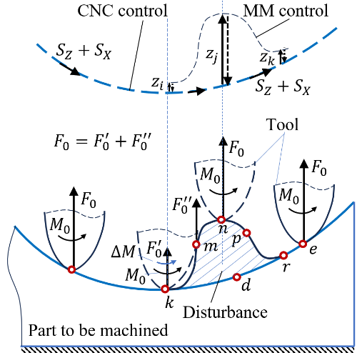
Fig. 1. Machining of a curved surface with a “locally increased stock allowance” (a) and tool path (b) |  | Fig. 2. Scheme of machining a curved surface with a “locally increased stock allowance”
The disappearance of the electric current in the circuit of the power source leads to the operation of the next unit. The corresponding signal is sent to the system units, which records not only the fact of the break in the electrical circuit, but also determines the value of the relative displacement $z_{i}>0$ of the moving element of the linear displacement sensor. This sensor consists of a movable part and a fixed part.
Next, the displacement signal $z_{i}>0$ is sent to the electronic unit. Here the value $Z_{0}$, which determines the vertical position of the tool in the CNC coordinate system (upper control level), is added to the specified displacement $z_{i}>0$. The computer receives information about the actual instantaneous axial coordinate of the tool $Z^{'}=Z_{0}+z_{i}$.
The value $z_{i}>0$ received by the computer generates two control signals, one of which stops the machine CNC system operation along the axes $XYZ$, at $Z=Z_{0}$, and the second increases the current in the circuit of the power source of the field winding by means of a block, which sets the variable value of the field current $I(X,Y,Z)$ according to a certain technological program. In this paper, this case is not considered, i.e., the value $I\left(X,Y,Z\right)=const$ at which $F=F_{0}$ and $M=M_{0}$.
The transition from a softer cutting mode to a hard one is possible by changing the configuration of the machining scheme. The traditional contour machining scheme, along with the axial cutting force $F$, is accompanied by lateral cutting forces on the tool, leading to increased wear of the bearings in which the spindle is installed.
And when the IMM system operates in the mode of stabilization of the force parameters $F$ and $M$ ($F=F_{0}$ and $M=M_{0}$), only axial forces act on the tool, which makes it possible to tighten the cutting modes (i.e., increase the specified levels $F_{0}$ and $M_{0}$) up to the closure of stops-contacts.
The closing of contacts by the armature end face is a signal for the computer, which passes through some units about the possibility of switching the MTS to the “stationary cutting mode” (from the CNC system at the upper control level). Thus, the closed state of stops-contacts is an indicator of the operation of the automatic control system at the upper control level, in which the IMM system is in the “standby” mode.
However, if the “disturbance” has not yet been removed, then the machine table movement along the axes $X$, $Y$ and $Z$ in the coordinate system $XYZ$ again leads to exceeding the cutting force parameters and to the rupture of stops-contacts. In this case, the process in the vertical cutting mode of the tool (the movement of the tool as when drilling only along the vertical axis) is repeated until the “disturbance” is removed (stops-contacts are closed) and the “servo cutting mode” switches to the “stationary cutting mode” according to the program set by the CNC upper control level. Transfer of control from the upper control level to the lower one and vice versa is automatic.
In general, the MTS operation in conditions of uncertainty occurs as if in the “stop-start” mode, i.e., the “stop” for the CNC upper control level system is the “start” for the operation of the IMM lower control level, and the “stop” of the latter is a signal to turn on the operation of the upper control level system. This happens until all deviations of the geometry of the machined surface from the programmed one are removed.
Conclusions. 1. The real environment in which automatic control systems (ACSs) operate has pronounced anisotropic properties. Under these conditions, ACSs must have the “feelings” and properties inherent in a living organism that maintains its vital activity in conditions of “uncertainty”. 2. A methodology for two-level (hierarchical) control of the operation of a mechatronic technological system for mechanical machining based on a CNC machine and a mechatronic spindle containing an intelligent mechatronic mechanism (IMM) has been developed. At the upper control level, the kinematic parameters of mechanical machining (speed, acceleration, displacement) are selected and stabilized, and at the lower level, the power parameters (cutting axial force and torque) are stabilized and changed according to the technological program. 3. At both control levels, closed ACSs “by deviation” of the controlled parameters from the set values ​​are used. At the same time, the ACS at the lower level in relation to the similar ACS at the upper level is an ACS “by disturbance”.
REFERENCE
1. Lima U., Sarides G. N. “Design of intelligent control systems based on hierarchical stochastic automata”. World Scientific Publishing Co. Pte.Ltd. Singapore. 1996.
2. Larshin V., Gushchin A. M. “Information support of mechatronic technological systems”. Applied Aspects of Information Technology. 2021; 4 (2): 153–167.
DOI: https://doi.org/10.15276/aait.02.2021.3.
3. Gushchin A. M., Larshin V., Lysyi O. V. “Information model of adaptive mechatronic mechanism”. Applied Aspects of Information Technology. 2022; 5 (2): 105–119.
DOI: https://doi.org/10.15276/aait.05.2022.8.
4. Gil Del Val, A., Veiga, F., Suárez, A., Arizmendi, M. “Thread quality control in high-speed tapping cycles”. J. Manuf. Mater. Process. 2020. 4, 9. DOI: https://doi.org/10.3390/jmmp4010009.
5. Gil Del Val, A., Veiga, F., Penalva, M., Arizmendi, M. “Oversizing thread diagnosis in tapping operation”. Metals. 2021. 11(4), 537. DOI: https://doi.org/10.3390/met11040537.
6. Larshin, V.P., Gushchin, A.M. “Mechatronic technological system information support”. Appl. Aspects Inform. Technol. 2021. 4(2), 153–167. DOI: https://doi.org/10.15276/aait.02.2021.3
7. Gushchin, A., Larshin, V., Marchuk, V. “CNC machine adaptive control mechatronic module”. In: Radionov, Andrey A., Gasiyarov, Vadim R. (eds.) Proceedings of the 8th International Conference on Industrial Engineering: ICIE 2022, pp. 154–163. Springer International Publishing. 2023. Cham. DOI: https://doi.org/10.1007/978-3-031-14125-6_16.
8. Vavruska P., Bartos F., Pesice M. “Effective feed rate control to maintain constant feed per tooth along toolpaths for milling complex-shaped parts”. International Journal of Advanced Manufacturing Technology. 2023; 128: 3215–3232. DOI: https://doi.org/10.1007/s00170-023-12143-0.
9. Rudel V., Kienast P., Vinogradov G., Ganser P., Bergs T. “Cloud-based process design in a digital twin framework with integrated and coupled technology models for blisk milling”. Frontiers in Manufacturing Technology. 2022; 2. DOI: https://doi.org/10.3389/fmtec. 2022.1021029.
10. De Silva, C.W. “Mechatronics: a foundation course”. CRC Press/Taylor & Francis. 2010. Boca Raton.
11. Billingsle, J. “Essential of mechatronics”. John Wiley & Sons. 2006. Inc., Hoboken, New Jersey.
12. de Silva, C.W. (ed.). “Mechatronic systems: Devices, design, control, operation and monitoring”. CRC Press. 2007. DOI: https://doi.org/10.1201/9780849307768.
13. Dobrinski A., Möhring H.-C., Stehle T. “Development of an adaptronic spindle for a faultless machining of homogeneous and inhomogeneous materials”. J. Mach. Eng. 2021. 21(2), 5–23. DOI: https://doi.org/10.36897/jme/136277.
14. Steininger A., Siller A., Bleicher F. “Investigations regarding process stability aspects in thread tapping AL-SI alloys”. Procedia Eng. 2015. 100, 1124–1132. DOI: https://doi.org/10.1016/j.proeng.2015.01.475.
15. Dobrinski A., Dudarev, A. “Intelligent automated drilling in the laminate composites and hybrid materials”. Mater. Today: Proc. 2021. 38(4), 1980–1983. https://doi.org/10.1016/j. matpr.2020.09.723.
16. Shimana K., et al. “Surface integrity of machined surface in simultaneous cutting of CFRP”. J. Mach. Eng. 2020. 20(1), 98–106. DOI: https://doi.org/10.36897/jme/117781.
17. Sultana I., Shi Z., Attia M. H., Thomson V. “Surface integrity of holes machined by orbital drilling of composites with single layer diamond tools”. Procedia CIRP. 2016. 45, 23–26.
18. Fleischer J., Teti R., Lanza G., Mativenga P., Möhring H.-C., Caggiano A. “Composite materials parts manufacturing”. CIRP Annals. 2018. 67(2), 603–626. DOI: https://doi.org/10.1016/j.cirp.2018.05.005.
19. de Silva C.W. “Sensors and actuators: Engineering system instrumentation”, 2nd edn. CRC Press. 2015. Boca Raton. DOI: https://doi.org/10.1201/b18739.
DOI: https://doi.org/10.15276/ict.01.2024.47
УДК 004.942 + 621.923
Мехатронна технологічна система на основі ЧПК та
інтелектуального мехатронного механізму
Ларшин Василь Петрович¹⁾
Академік Української академії економічної кібернетики
Д-р техніч. наук, професор, каф. Динаміки машин та механічної інженерії
ORCID: https://orcid.org/0000-0001-7536-3859; vasilylarshin@gmail.com. Scopus Author ID: 7801669969
Гущин Анатолій Михайлович¹⁾
Канд. техніч. наук, доцент у відставці
ORCID: https://orcid.org/0000-0002-1289-9557; guschinanatoliy1@gmail.com
Лисий Олександр Васильович²⁾
Канд. техніч. наук, доцент каф. Автомобільної техніки, начальник каф. Автомобільної техніки
ORCID: https://orcid.org/0000-0002-7389-1161; lenafox107@gmail.com
Верпівський Сергій Миколайович²⁾
Заступник начальника каф. Автомобільної техніки
ORCID: https://orcid.org/0000-0002-1610-4707; vsn1964@ukr.net
Бучка Егор Володимирович¹⁾
Аспірант каф. Динаміки машин та механічної інженерії
ORCID: https://orcid.org/0000-0003-4786-9283; yehorbuchka@gmail.com
¹⁾ Національний університет «Одеська політехніка», пр. Шевченка, 1. Одеса, 65044, Україна
²⁾ Військова Академія (м. Одеса), Фонтанська дорога, 10. Одеса, 65009, Україна
АНОТАЦІЯ
Розроблено мехатронну технологічну систему (МТС), що складається з металорізального верстата з ЧПК та мехатронного шпинделя, який виконано на основі інтелектуального мехатронного механізму (ІММ). Основні елементи технологічної системи – пристрої ЧПУ та ІММ – входять до складу єдиної ієрархічної дворівневої системи управління, представляючи відповідно верхній та нижній рівні управління в цій системі. Верхній рівень – пристрій ЧПУ – забезпечує стабілізацію кінематичних параметрів обробки (переміщення, швидкість, прискорення) та їх програмну зміну відповідно до керуючої програми ЧПК. Нижній рівень – пристрій ІММ – забезпечує стабілізацію силових параметрів механічної обробки (осьова сила та крутний момент різання) та їх програмна зміна відповідно до технологічних вимог до якості поверхні та фізико-механічного стану поверхневого шару оброблюваних деталей. На обох рівнях управління функціонують замкнуті системи автоматичного управління «з відхилення» регульованих кінематичних (верхній рівень управління) і силових (нижній рівень управління) параметрів механічної обробки. Причому система автоматичного управління нижнього рівня ієрархії по відношенню до аналогічної системи автоматичного управління верхнього рівня реалізує спосіб автоматичного управління «з обурення». Це, крім прямого забезпечення якості поверхні та необхідного її фізико-механічного стану, дозволяє покращити якість стабілізації кінематичних параметрів різання на верхньому рівні управління. Експериментальні дослідження МТС які виконані при обробці деталей з різних матеріалів (сталь, полімерні композиційні матеріали, надтверді кристали та каміння, інші матеріали, що важко обробляються).
Ключові слова: технологія ремонту автомобілів; механічна обробка; розумне різання; осьова сила різання; крутний момент різання; числове програмне керування; інтелектуальний мехатронний механізм; лінійний привід

